Potato Chips Brands
Student’s name
Institutional affiliation
Course-name
Course-code
Date of submission

Whether chilling in front of a TV, having a house a party, or having the family for a barbecue, one guaranteed thing to be present is a bag of chips since potato chips are decidedly one of the best go-to snacks. According to Rompay & Groothedde, 2019, in selecting the best potato chips for the occasion, there are several dependants to consider, perhaps their flavor and crunchiness being the best dependant. Even if you have the best chip with you, but the taste is not appealing, you won’t probably enjoy the snack as expected. Similarly, you require pairing the chip to a dip for flavor possibilities maximization. For this reason, I would like to compare the brands of potato chips junk foods to assess the food item quality and the likelihood that an individual would buy a specific brand.
I chose and bought the three potato chips brand types: the Market Pantry chips, the Lay's Classic Chips, and the Good and Gather Kettle-cooked Sea Salt Potato Chips brands. Including a range of their flavors for their quality assessment and determining the factors that influence the probability that an individual would purchase my chosen brand. In this case, the Lay's Classic Chips, which will be my dependent variable when enjoying with my family members, turned out to take the top rank in our taste test. Basing on its flavor and characteristics, which are my independent variables for the chips measurement quality and our responses in the taste test. Additionally, the brand crunchiness is just right hence having the upper hand in the considerations. Owing to the nostalgia factor, the brand held up as the right greasy and salty chip. It is flavorful, thin, and delicious, and there is likelihood to be bought by someone else.
Compared to the Market Pantry Chips and the Good and Gather Kettle-cooked Sea Salt Potato Chips, Lay's Classic Chips presents something extra different compared to other average options for the potato chip. The level of flavor is definitely on another level. The chips combine jalapeno and cheddar, which gives a taste and a flavor of onion and healthy sour cream that, is hard to beat. Additionally, Lay's Classic Chips are made from real potatoes where the skin is left aside for the chip's thick, crunchy style production. This gives it an appealing style and increases other people's likelihood to buy the potato chip brand.
Conversely, the Lay’s Classic Chips are trans-fat-free and can easily be mixed with dips for more complex flavor experience. Fat-free chips are one of the considerations of most potato chips consumers—it improves the quality of this brand, which increases its likelihood of being bought by other individuals. The brand is also regarded as the thickest chip, a preferable characteristic to most of the consumers.
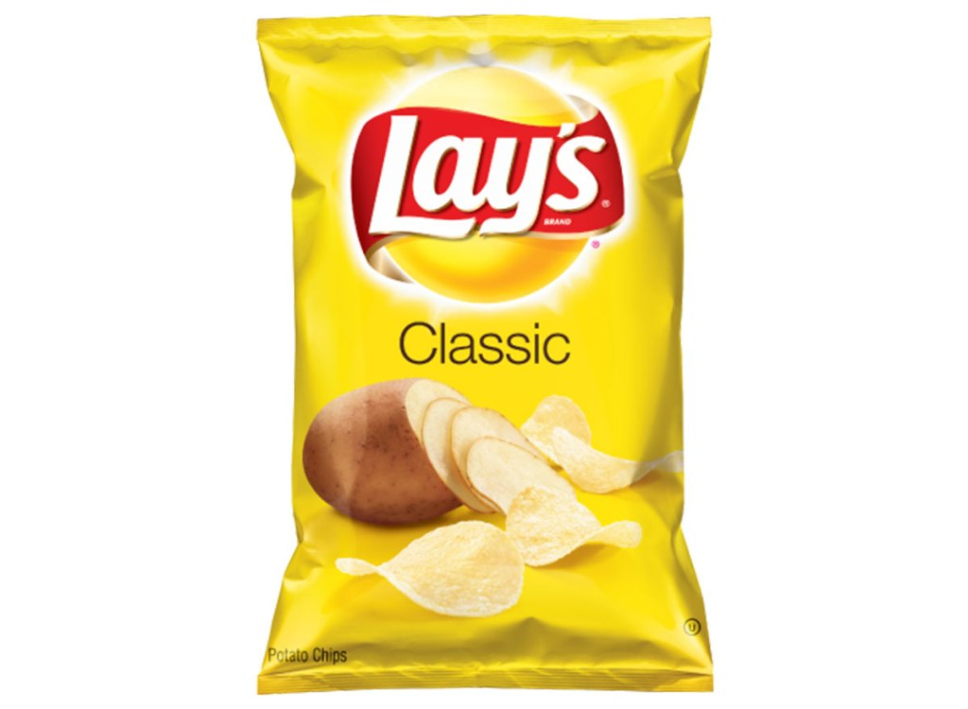
Lay’s Classic Chips
For the Market Pantry Chips and the Good and Gather Kettle-cooked Sea Salt Potato chips, I wouldn't say I like their crunchiness and as their flavor and tastes more like the Lay’s Classic Chips. The Market Pantry Chips are too crunchy and lack salt, and they lack flavor; and on the other hand, the Good and Gather Kettle-cooked Sea Salt Potato Chips poses a cheese flavor that is addicting. The flavors and qualities of these brands are not my favorites.
Market Pantry Potato Chips
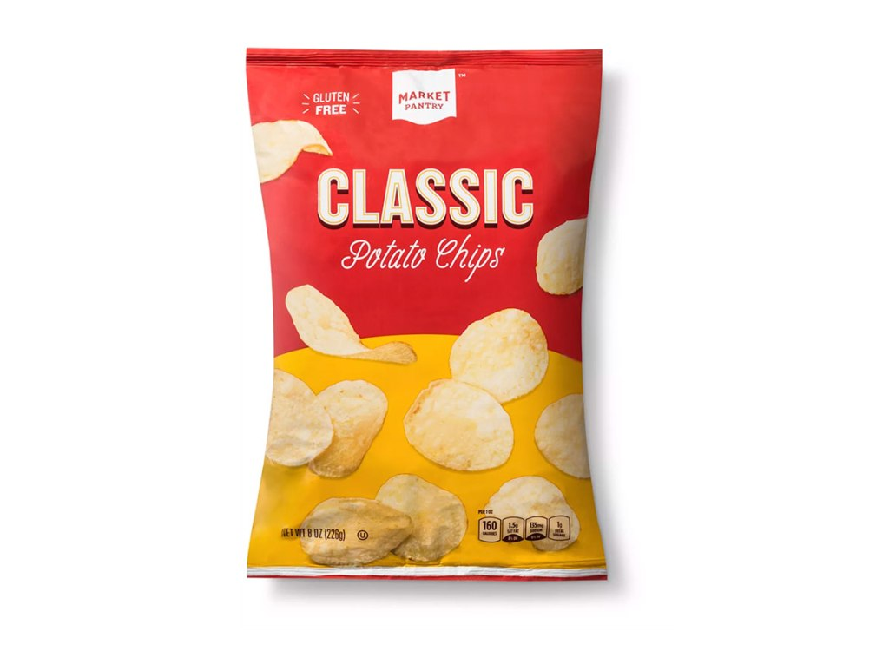
Kettle Cooked Sea Salt Potato Chips 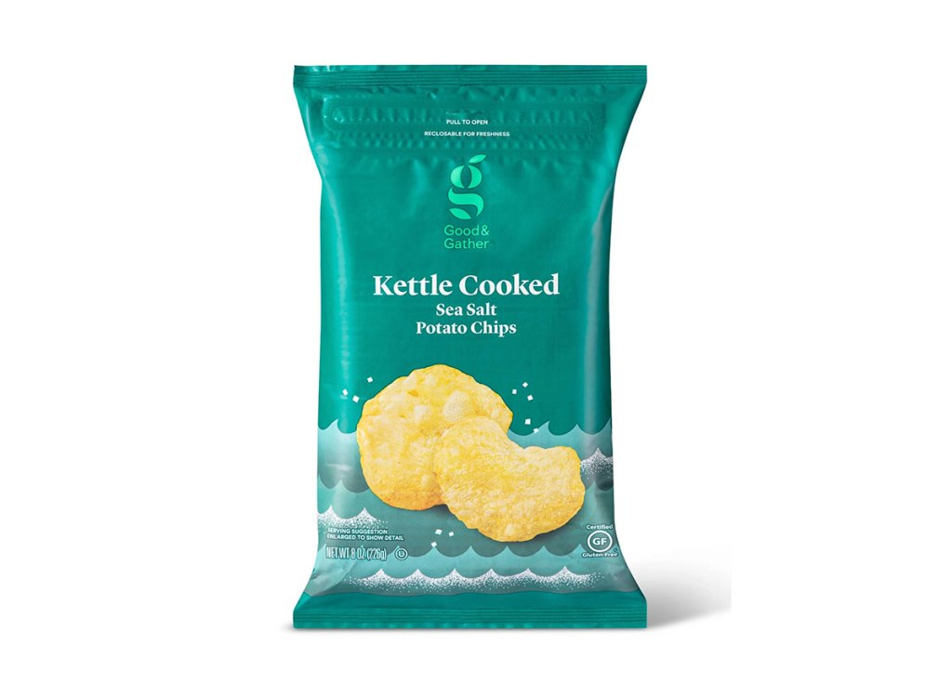

Potato chips may appear like a straightforward snack, although the quality can tremendously vary from one brand to another. You may require a chip with just the appropriate crunch amount, salty though not too salty and probably with the correct thickness. Having that in consideration, the brand with the features results in the absolute best potato chip (Rompay & Groothedde, 2019).

REFERENCES
https://www.eatthis.com/best-potato-chips/
van Rompay, T. J., & Groothedde, S. (2019). The taste of touch: Enhancing saltiness impressions through surface texture design. Food quality and preference, 73, 248-254.

